# NANDHA ENGINEERING COLLEGE

## (Autonomous)

### Erode-638 052



**PROJECT BASED LEARNING REPORT**

***Submitted by***

**K.SIVAKUMAR(17CS093)**

**K.SELVA GANESH(17CS091)**

**P.RAMAKRISHNAN(17CS081)**

**D.SATHYAMOORTHI(17CS090)**

**V.V.SANJEETH(17CS089)**

**in partial fulfillment for the award of the degree of**

**B.E- COMPUTER SCIENCE AND ENGINEERING**

#### 17ITC01-OOPS USING JAVA

#### II YEAR / III – Semester

## BONAFIDE CERTIFICATE

Certified that this Report titled “BANKING SYSTEM” is the bonafide work of **K.SIVAKUMAR-(17CS093), K.SELVAGANESH-(17CS091),P.RAMAKRISHNAN-(17CS081),D.SATHYAMOORTHI-(17CS090) ,V.V.SANJEETH-(17CS089)-** who carried out the work under my supervision. Certified further, that to the best of my knowledge the work reported herein does not form part of any other project report or dissertation on the basis of which a degree or award was conferred on an earlier occasion on this or any other candidate

**Ms. P.Dhivya, Mr.K.GUNASEKARAN**

Assistant Professor, Professor and Head,

Department of IT, Department of CSE,

Nandha Engineering College Nandha Engineering College

(Autonomous) (Autonomous)

Erode-638052. Erode-638052.

**Submitted for the Project Viva Voice Examination held on** ___________.

**INTERNAL EXAMINER**

**ACKNOWLEDGEMENT**

I express my thanks to our beloved Chairman of Sri Nandha Educational Trust **Thiru. V.Shanmugan** and our beloved Secretaries,**Thiru. S.Nandhakumar Pradeep** of Sri Nandha Educational Trust and **Thiru. S.Thirumoorthi** of Nandha Educational Institutions for providing me all the basic amenities to complete the course successfully.

I specially thank **Dr. S.Arumugam,** Chief Executive Officer of Nandha Educational Institutions for his affection and support in all aspects have made me to complete the course successfully.

I wish to convey my earnest gratefulness to our cherished Principal of Nandha Engineering College, **Dr. N.Rengarajan, ME., Ph.D.,** for his constant support in my successful completion of my project work.

I articulate my genuine and sincere thanks to our dear hearted Head of the Department of Computer Engineering **K.Gunasekar.,** who has been the key spring of motivation to me throughout the completion of my course and my project work.

I wish to convey my hearty thanks to my beloved Project Supervisor **Ms. P.DHIVYA, M.E.,** Assistant Professor, Department of Information Technology for his continuous monitoring for the project work.

I am very much gratified to all teaching and non-teaching staff of our department who were direct and indirect stroke throughout my progress. I would like to acknowledge my heartfelt thanks to my parents and my friends who have supported me with their unconditional love and encouragement. Finally, I would like to thank the Almighty for his blessings.

(K.SIVA KUMAR, K.SELVA GANESH, P.RAMA KRISHNAN, D.SATHYAMOORTHI, VV.SANJEETH)

|  |  |  |
| --- | --- | --- |
| **TABLE OF CONTENTS** | | |
|  | | |
| **CHAPTER NO.** | **T ITLE** | **PAGE NO** |
|  | **ABSTRACT** |  |
|  | **LIST OF FIGURES** |  |
|  | **LIST OF ABBREVIATIONS** |  |
|  |  |  |
| **1** | **INTRODUCTION** |  |
|  | 1.1 OVERVIEW OF THE PROJECT | 7 |
|  | 1.2 OBJECTIVE OF THE PROJECT | 8 |
|  | 1.3 SYSTEM ARCHITECTURE | 9 |
|  |  |  |
| **2** | **MODULES** |  |
|  | 2.1 MANAGER LOGIN | 10 |
|  | 2.2 USER LOGIN  2.3 ACCOUNT DETAILS  2.4 TRANSACTION DETAILS | 10  10  10 |
|  |  |  |
|  |  |  |
|  |  |  |
|  |  |  |
| **CHAPTER NO** | **TITLE** | **PAGE NO** |
| **3** | **PROBLEM DESCRIPTION** |  |
|  | 3.1 EXISTING SYSTEM | 11 |
|  | 3.1.1 Problems in Existing System | 11 |
|  | 3.2 PROPOSED SYSTEM | 11 |
|  | 3.2.1 Advantage of Proposed System | 11 |
|  |  |  |
|  | **SYSTEM REQUIREMENTS** |  |
| **4** | 4.1 Hardware Configurations | **12** |
|  | 4.2 Software Requirements | **12** |
|  | 4.3 Software Descriptions | **12** |
|  |  |  |
| **5** | **SYSTEM IMPLEMENTATION** |  |
|  | 5.1 Proposed System | **13** |
|  | 5.3 System Flow Diagram | **13** |
|  |  |  |
| **6** | **CONCLUSION** | **14** |
| **7** | **SOURCE CODE** | **15** |
|  |  |  |
| **8** | **SCREEN SHOTS** | **40** |
|  |  |  |
| **9** | **REFERENCES** | **53** |

**ABSTRACT**

The Bank Account Management System is an application for maintaining a person's account in a bank. In this project I tried to show the working of a banking account system and cover the basic functionality of a Bank Account Management System. To develop a project for solving financial applications of a customer in banking environment in order to nurture the needs of an end banking user by providing various ways to perform banking tasks. The main aim of this project is to develop software for Bank Account Management System. This project has been developed to carry out the processes easily and quickly, which is not possible with the manuals systems, which are overcome by this software. This project is developed using JAVA language and MYSQL use for database connection. Organization need to effectively define and manage requirements to ensure they are meeting needs of the customer, while proving compliance and staying on the schedule and within budget. The impact of a poorly expressed requirement can bring a business out of compliance or even cause injury or death. Requirements definition and management is an activity that can deliver a high, fast return on investment. The project analyzes the system requirements and then comes up with the requirements specifications. It studies other related systems and then come up with system specifications. The system is then designed in accordance with specifications to satisfy the requirements. The system design is then implemented with MYSQL. The system is designed as an interactive and content management system. The content management system deals with data entry, validation confirm and updating whiles the interactive system deals with system interaction with the administration and users. Thus, above features of this project will save transaction time and therefore increase the efficiency of the system

**CHAPTER – 1**

* **INTRODUCTION**

**1.1OVERVIEW OF THE PROJECT:**

The main object of this system is to provide a secure system. Our system is password protected and it only allows authorized user to access various functions available in the system.

 It will Reduced manual work as most of the work done by computer. As all the manual work will be done automatically so it will increase work speed and reduce time consumption to complete any bank related work. It will also increase the work efficiency as few employees can handle more customers.  This will reduced the manual workload and give information instantly.

The Project Banking system has been made to automate the Banking system. Using this bank management system user can check his account detail online like balance in account, bank statement etc.  The Administrator can check bank account with a login can work out with A/C holders from their accounts. This system is also help bank user to create New account easily. The project makes a sincere effort to provide all the below-mentioned features to meet the requirements of the bank.

In this bank management system use can also search record of a particular Account Holder.

**1.2 OBJECTIVE OF THE PROJECT:**

* The project has a very vast scope in future. The project can be implemented on intranet in future.
* Project can be updated in near future as and when requirement for the same arises, as it is very flexible in terms of expansion. With the proposed software of database Space Manager ready and fully functional the client is now able to manage and hence run the entire work in a much better, accurate and error free manner.
  1. **SYSTEM ARCHITECTURE:**

**Figure 1.1 System Architecture**

**CHAPTER - 2**

**MODULES**

* Login
* User login
* Account details
* Transaction details
* Click on Login to enter into the Home Page.
* Fill the your details in username and password field
* /If you entered wrong username or password the “username and password not matched” message will be thrown.
* In that case click Reset button then fill your details
* Fill your Account Number and IFSC code
* If you entered wrong Account Number or IFSC “invalid user “ the message will be thrown. Then reset and fill the details
* If the details given is matched, then your personal details will be shown
* You will see the transactions details will be shown

**CHAPTER - 3**

**PROBLEM DESCRIPTION**

**3.1 EXISTING SYSTEM:**

* The existing system is not effective.
* It has more consumption of space.
* It has more bugs and lags.

**3.1.1 ADVANTAGES OF PROPOSED SYSTEM**

* It is Safe, Secure and Reliable.
* It is user friendly.
* It has low consumption of space.
* It is easy for the managers to check the details.

**3.1.2 DISADVANTAGES OF EXISTING SYSTEM:**

* It is not secured.
* It has limited number of storage capacity.
* It is non-user friendly.
* It is not maintained properly.
* It is difficult for the managers to check the details.

**3.2PROPOSED SYSTEM:**

* The software is based on JAVA Language.
* It is used for bank managers.
* It is used to hold the users bank details.

**CHAPTER - 4**

**SYSTEM REQUIREMENTS**

**4.1 HARDWARE CONFIGURATION:**

System : HP

Processor : Icor 3

RAM : 4GB RAM

Hard Disk Capacity : 1 TB

**4.2 SOFTWARE REQUIREMENTS:**

Operating System : Windows XP/ Windows 7/8/8.1/10

Front end : NetBeansIDE

Back end : MySql

**4.3 SOFTWARE DESCRIPTION:**

This document provides a very simple and quick introduction to the NetBeans IDE workflow by walking you through the creation of a simple "Hello World" Java console application. Once you are done with this tutorial, you will have a general knowledge of how to create and run applications in the IDE.Java Swing tutorial is a part of Java Foundation Classes (JFC) that is used to create window-based applications. It is built on the top of AWT (Abstract Windowing Toolkit) API and entirely AWT, Java Swing provides platform-independent and lightweight components.

**CHAPTER – 5**

**SYSTEM IMPLEMENTATION**

**5.1 PROPOSED SYSTEM:**

* The software is based on JAVA Language.
* It is used for Banking transactions and banking details
* The user first need to create the user name and password..
* It is used to hold the users bank details.

**CHAPTER - 6**

**CONCLUSION**

* This Application is very useful for the people who always use banking for their transactions.
* It is very easy to know about the banking details, otherwise you need to go to the bank and need to stand in a Queue and that will affect your time.
* By having in your place, we can easily can get the details about the banking details , so that we can save our precious time and can avoid to struggle in crowd

**CHAPTER - 7**

**SOURCE CODE**

**MANAGER LOGIN**

import java.sql.*;

import javax.swing.JOptionPane;

public class login extends javax.swing.JFrame {

public login() {

initComponents(); }

private void initComponents() {

jPanel1 = new javax.swing.JPanel();

jLabel1 = new javax.swing.JLabel();

jLabel2 = new javax.swing.JLabel();

jLabel3 = new javax.swing.JLabel();

txt_username = new javax.swing.JTextField();

txt_password = new javax.swing.JPasswordField();

login = new javax.swing.JButton();

reset = new javax.swing.JButton();

setDefaultCloseOperation(javax.swing.WindowConstants.EXIT_ON_CLOSE);

jPanel1.setLayout(null);

jLabel1.setFont(new java.awt.Font("Times New Roman", 1, 24)); // NOI18N

jLabel1.setText("BANKING SYSTEM");

jPanel1.add(jLabel1);

jLabel1.setBounds(130, 30, 220, 20);

jLabel2.setFont(new java.awt.Font("Times New Roman", 0, 16)); // NOI18N

jLabel2.setText("username:");

jPanel1.add(jLabel2);

jLabel2.setBounds(30, 120, 70, 20);

jLabel3.setFont(new java.awt.Font("Times New Roman", 0, 16)); // NOI18N

jLabel3.setText("password:");

jPanel1.add(jLabel3);

jLabel3.setBounds(30, 200, 70, 20);

jPanel1.add(txt_username);

txt_username.setBounds(120, 120, 230, 30);

jPanel1.add(txt_password);

txt_password.setBounds(120, 200, 230, 30);

login.setText("LOGIN");

login.addActionListener(new java.awt.event.ActionListener() {

public void actionPerformed(java.awt.event.ActionEvent evt) {

loginActionPerformed(evt);

}

});

jPanel1.add(login);

login.setBounds(120, 290, 80, 23);

reset.setText("RESET");

reset.addActionListener(new java.awt.event.ActionListener() {

public void actionPerformed(java.awt.event.ActionEvent evt) {

resetActionPerformed(evt);

}

});

jPanel1.add(reset);

reset.setBounds(273, 290, 80, 23);

javax.swing.GroupLayout layout = new javax.swing.GroupLayout(getContentPane());

getContentPane().setLayout(layout);

layout.setHorizontalGroup(

layout.createParallelGroup(javax.swing.GroupLayout.Alignment.LEADING)

.addComponent(jPanel1, javax.swing.GroupLayout.PREFERRED_SIZE, 430, javax.swing.GroupLayout.PREFERRED_SIZE)

);

layout.setVerticalGroup(

layout.createParallelGroup(javax.swing.GroupLayout.Alignment.LEADING)

.addComponent(jPanel1, javax.swing.GroupLayout.PREFERRED_SIZE, 355, javax.swing.GroupLayout.PREFERRED_SIZE)

);

pack();

}

private void loginActionPerformed(java.awt.event.ActionEvent evt) {

String s1=txt_username.getText();

String s2=new String(txt_password.getPassword());

try

{

Class.forName("com.mysql.jdbc.Driver");

Connection con=DriverManager.getConnection("jdbc:mysql://localhost:3306/bank","root","root");

Statement stmt=con.createStatement();

String query="select * from login where userid='"+s1+"' and passwd='"+s2+"'";

ResultSet rs=stmt.executeQuery(query);

if(rs.next())

{

JOptionPane.showMessageDialog(null,"username and password matched");

userlogin u=new userlogin();

u.setVisible(true);

this.dispose();

}

else

{

JOptionPane.showMessageDialog(null,"username and password not match");

System.exit(0);

}

}

catch(Exception ex)

{

JOptionPane.showMessageDialog(null,"login failed");

}

}

private void resetActionPerformed(java.awt.event.ActionEvent evt) {

txt_username.setText("");

txt_password.setText("");

}

public static void main(String args[]) {

try {

for (javax.swing.UIManager.LookAndFeelInfo info : javax.swing.UIManager.getInstalledLookAndFeels()) {

if ("Nimbus".equals(info.getName())) {

javax.swing.UIManager.setLookAndFeel(info.getClassName());

break;

}

}

} catch (ClassNotFoundException ex) {

java.util.logging.Logger.getLogger(login.class.getName()).log(java.util.logging.Level.SEVERE, null, ex);

} catch (InstantiationException ex) {

java.util.logging.Logger.getLogger(login.class.getName()).log(java.util.logging.Level.SEVERE, null, ex);

} catch (IllegalAccessException ex) {

java.util.logging.Logger.getLogger(login.class.getName()).log(java.util.logging.Level.SEVERE, null, ex);

} catch (javax.swing.UnsupportedLookAndFeelException ex) {

java.util.logging.Logger.getLogger(login.class.getName()).log(java.util.logging.Level.SEVERE, null, ex);

}

java.awt.EventQueue.invokeLater(new Runnable() {

public void run() {

new login().setVisible(true);

}

});

}

private javax.swing.JLabel jLabel1;

private javax.swing.JLabel jLabel2;

private javax.swing.JLabel jLabel3;

private javax.swing.JPanel jPanel1;

private javax.swing.JButton login;

private javax.swing.JButton reset;

private javax.swing.JPasswordField txt_password;

private javax.swing.JTextField txt_username;

}

**1.USER LOGIN**

import java.sql.*;

import javax.swing.JOptionPane;

public class userlogin extends javax.swing.JFrame {

public userlogin() {

initComponents();

}

private void initComponents() {

jPanel1 = new javax.swing.JPanel();

jLabel1 = new javax.swing.JLabel();

jLabel2 = new javax.swing.JLabel();

jLabel3 = new javax.swing.JLabel();

accountnumber = new javax.swing.JTextField();

ifsccode = new javax.swing.JTextField();

login = new javax.swing.JButton();

reset = new javax.swing.JButton();

setDefaultCloseOperation(javax.swing.WindowConstants.EXIT_ON_CLOSE);

jPanel1.setLayout(null);

jLabel1.setFont(new java.awt.Font("Times New Roman", 0, 14)); // NOI18N

jLabel1.setText("ACCOUNT LOGIN");

jPanel1.add(jLabel1);

jLabel1.setBounds(200, 30, 120, 17);

jLabel2.setFont(new java.awt.Font("Times New Roman", 0, 12)); // NOI18N

jLabel2.setText("ACCOUNT NUMBER:");

jPanel1.add(jLabel2);

jLabel2.setBounds(20, 120, 130, 14);

jLabel3.setFont(new java.awt.Font("Times New Roman", 0, 12)); // NOI18N

jLabel3.setText("IFSC CODE:");

jPanel1.add(jLabel3);

jLabel3.setBounds(30, 200, 90, 14);

jPanel1.add(accountnumber);

accountnumber.setBounds(160, 110, 290, 30);

jPanel1.add(ifsccode);

ifsccode.setBounds(160, 190, 290, 30);

login.setText("LOGIN");

login.addActionListener(new java.awt.event.ActionListener() {

public void actionPerformed(java.awt.event.ActionEvent evt) {

loginActionPerformed(evt);

}

});

jPanel1.add(login);

login.setBounds(160, 260, 80, 30);

reset.setText("RESET");

reset.addActionListener(new java.awt.event.ActionListener() {

public void actionPerformed(java.awt.event.ActionEvent evt) {

resetActionPerformed(evt);

}

});

jPanel1.add(reset);

reset.setBounds(363, 260, 80, 23);

javax.swing.GroupLayout layout = new javax.swing.GroupLayout(getContentPane());

getContentPane().setLayout(layout);

layout.setHorizontalGroup(

layout.createParallelGroup(javax.swing.GroupLayout.Alignment.LEADING)

.addComponent(jPanel1, javax.swing.GroupLayout.PREFERRED_SIZE, 502, javax.swing.GroupLayout.PREFERRED_SIZE)

);

layout.setVerticalGroup(

layout.createParallelGroup(javax.swing.GroupLayout.Alignment.LEADING)

.addComponent(jPanel1, javax.swing.GroupLayout.PREFERRED_SIZE, 318, javax.swing.GroupLayout.PREFERRED_SIZE)

);

pack();

}

private void loginActionPerformed(java.awt.event.ActionEvent evt) {

String s1=accountnumber.getText();

String s2=ifsccode.getText();

Accountdetails a = new Accountdetails();

boolean flag = false;

try

{

Class.forName("com.mysql.jdbc.Driver");

Connection con=DriverManager.getConnection("jdbc:mysql://localhost:3306/bank","root","root");

Statement stmt=con.createStatement();

String query="select * from userlogin where accno='"+s1+"' and ifsc='"+s2+"'";

ResultSet rs=stmt.executeQuery(query);

while(rs.next())

{

flag = true;

JOptionPane.showMessageDialog(null,"valid user");

Accountdetails t=new Accountdetails();

t.setVisible(true);

this.dispose();

String query1="select * from accdetails";

ResultSet rs1=stmt.executeQuery(query1);

while(rs1.next())

{

System.out.println(rs1.getString(1));

Accountdetails.name.setText(rs1.getString(1));

System.out.println(rs1.getString(2));

Accountdetails.dob.setText(rs1.getString(2));

System.out.println(rs1.getString(3));

Accountdetails.address.setText(rs1.getString(3));

System.out.println(rs1.getString(4));

Accountdetails.accnumber.setText(rs1.getString(4));

System.out.println(rs1.getString(5));

Accountdetails.ifsc.setText(rs1.getString(5));

System.out.println(rs1.getString(6));

Accountdetails.cif.setText(rs1.getString(6));

}

}

if(flag)

{

JOptionPane.showMessageDialog(null,"invalid user");

}

}

catch(Exception ex)

{

}

}

private void resetActionPerformed(java.awt.event.ActionEvent evt) {

accountnumber.setText("");

ifsccode.setText("");

}

public static void main(String args[]) {

java.awt.EventQueue.invokeLater(new Runnable() {

public void run() {

new userlogin().setVisible(true);

}

});

}

private javax.swing.JTextField accountnumber;

private javax.swing.JTextField ifsccode;

private javax.swing.JLabel jLabel1;

private javax.swing.JLabel jLabel2;

private javax.swing.JLabel jLabel3;

private javax.swing.JPanel jPanel1;

private javax.swing.JButton login;

private javax.swing.JButton reset;

}

ACCOUNT DETAILS

import java.sql.*;

import javax.swing.JOptionPane;

public class Accountdetails extends javax.swing.JFrame {

public Accountdetails() {

initComponents();

}

@SuppressWarnings("unchecked")

private void initComponents() {

jPanel1 = new javax.swing.JPanel();

jLabel1 = new javax.swing.JLabel();

jLabel2 = new javax.swing.JLabel();

jLabel3 = new javax.swing.JLabel();

jLabel4 = new javax.swing.JLabel();

jLabel5 = new javax.swing.JLabel();

jLabel6 = new javax.swing.JLabel();

jLabel7 = new javax.swing.JLabel();

next = new javax.swing.JButton();

name = new javax.swing.JTextField();

dob = new javax.swing.JTextField();

cif = new javax.swing.JTextField();

accnumber = new javax.swing.JTextField();

ifsc = new javax.swing.JTextField();

jScrollPane1 = new javax.swing.JScrollPane();

address = new javax.swing.JTextArea();

setDefaultCloseOperation(javax.swing.WindowConstants.EXIT_ON_CLOSE);

jPanel1.setLayout(null);

jLabel1.setFont(new java.awt.Font("Times New Roman", 1, 12)); // NOI18N

jLabel1.setText("NAME :");

jPanel1.add(jLabel1);

jLabel1.setBounds(50, 110, 140, 14);

jLabel2.setFont(new java.awt.Font("Times New Roman", 1, 12)); // NOI18N

jLabel2.setText("DATE OF BIRTH :");

jPanel1.add(jLabel2);

jLabel2.setBounds(50, 160, 140, 14);

jLabel3.setFont(new java.awt.Font("Times New Roman", 1, 14)); // NOI18N

jLabel3.setText("ACCOUNT DETAILS");

jPanel1.add(jLabel3);

jLabel3.setBounds(310, 20, 140, 17);

jLabel4.setFont(new java.awt.Font("Times New Roman", 1, 12)); // NOI18N

jLabel4.setText("ADDRESS :");

jPanel1.add(jLabel4);

jLabel4.setBounds(50, 210, 140, 14);

jLabel5.setFont(new java.awt.Font("Times New Roman", 1, 12)); // NOI18N

jLabel5.setText("ACCOUNT NUMBER :");

jPanel1.add(jLabel5);

jLabel5.setBounds(50, 270, 140, 14);

jLabel6.setFont(new java.awt.Font("Times New Roman", 1, 12)); // NOI18N

jLabel6.setText("IFSC CODE :");

jPanel1.add(jLabel6);

jLabel6.setBounds(50, 320, 136, 14);

jLabel7.setFont(new java.awt.Font("Times New Roman", 1, 12)); // NOI18N

jLabel7.setText("CIF CODE :");

jPanel1.add(jLabel7);

jLabel7.setBounds(50, 370, 140, 14);

next.setText("NEXT");

next.addActionListener(new java.awt.event.ActionListener() {

public void actionPerformed(java.awt.event.ActionEvent evt) {

nextActionPerformed(evt);

}

});

jPanel1.add(next);

next.setBounds(630, 430, 80, 23);

name.setEnabled(false);

jPanel1.add(name);

name.setBounds(190, 100, 220, 30);

dob.setEnabled(false);

dob.addActionListener(new java.awt.event.ActionListener() {

public void actionPerformed(java.awt.event.ActionEvent evt) {

dobActionPerformed(evt);

}

});

jPanel1.add(dob);

dob.setBounds(190, 150, 220, 40);

cif.setEnabled(false);

jPanel1.add(cif);

cif.setBounds(190, 360, 220, 30);

accnumber.setEnabled(false);

accnumber.addActionListener(new java.awt.event.ActionListener() {

public void actionPerformed(java.awt.event.ActionEvent evt) {

accnumberActionPerformed(evt);

}

});

jPanel1.add(accnumber);

accnumber.setBounds(190, 260, 220, 30);

ifsc.setEnabled(false);

jPanel1.add(ifsc);

ifsc.setBounds(190, 310, 220, 30);

jScrollPane1.setEnabled(false);

address.setColumns(20);

address.setRows(5);

address.setEnabled(false);

jScrollPane1.setViewportView(address);

jPanel1.add(jScrollPane1);

jScrollPane1.setBounds(190, 200, 580, 40);

javax.swing.GroupLayout layout = new javax.swing.GroupLayout(getContentPane());

getContentPane().setLayout(layout);

layout.setHorizontalGroup(

layout.createParallelGroup(javax.swing.GroupLayout.Alignment.LEADING)

.addComponent(jPanel1, javax.swing.GroupLayout.PREFERRED_SIZE, 781, javax.swing.GroupLayout.PREFERRED_SIZE)

);

layout.setVerticalGroup(

layout.createParallelGroup(javax.swing.GroupLayout.Alignment.LEADING)

.addComponent(jPanel1, javax.swing.GroupLayout.DEFAULT_SIZE, 484, Short.MAX_VALUE)

);

pack();

}// </editor-fold>

private void nextActionPerformed(java.awt.event.ActionEvent evt) {

// TODO add your handling code here:

Transactiondetails o=new Transactiondetails();

o.setVisible(true);

this.dispose();

}

private void dobActionPerformed(java.awt.event.ActionEvent evt) {

// TODO add your handling code here:

}

private void accnumberActionPerformed(java.awt.event.ActionEvent evt) {

// TODO add your handling code here:

}

public static void main(String args[]) {

try {

for (javax.swing.UIManager.LookAndFeelInfo info : javax.swing.UIManager.getInstalledLookAndFeels()) {

if ("Nimbus".equals(info.getName())) {

javax.swing.UIManager.setLookAndFeel(info.getClassName());

break;

}

}

} catch (ClassNotFoundException ex) {

java.util.logging.Logger.getLogger(Accountdetails.class.getName()).log(java.util.logging.Level.SEVERE, null, ex);

} catch (InstantiationException ex) {

java.util.logging.Logger.getLogger(Accountdetails.class.getName()).log(java.util.logging.Level.SEVERE, null, ex);

} catch (IllegalAccessException ex) {

java.util.logging.Logger.getLogger(Accountdetails.class.getName()).log(java.util.logging.Level.SEVERE, null, ex);

} catch (javax.swing.UnsupportedLookAndFeelException ex) {

java.util.logging.Logger.getLogger(Accountdetails.class.getName()).log(java.util.logging.Level.SEVERE, null, ex);

}

java.awt.EventQueue.invokeLater(new Runnable() {

public void run() {

new Accountdetails().setVisible(true);

}

});

}

// Variables declaration - do not modify

public static javax.swing.JTextField accnumber;

public static javax.swing.JTextArea address;

public static javax.swing.JTextField cif;

public static javax.swing.JTextField dob;

public static javax.swing.JTextField ifsc;

private javax.swing.JLabel jLabel1;

private javax.swing.JLabel jLabel2;

private javax.swing.JLabel jLabel3;

private javax.swing.JLabel jLabel4;

private javax.swing.JLabel jLabel5;

private javax.swing.JLabel jLabel6;

private javax.swing.JLabel jLabel7;

private javax.swing.JPanel jPanel1;

private javax.swing.JScrollPane jScrollPane1;

public static javax.swing.JTextField name;

private javax.swing.JButton next;

// End of variables declaration

}

TRANSACTION DETAILS

public class Transactiondetails extends javax.swing.JFrame {

public Transactiondetails() {

initComponents();

}

@SuppressWarnings("unchecked")

private void initComponents() {

jLabel2 = new javax.swing.JLabel();

jScrollPane1 = new javax.swing.JScrollPane();

trans = new javax.swing.JTable();

setDefaultCloseOperation(javax.swing.WindowConstants.EXIT_ON_CLOSE);

getContentPane().setLayout(null);

jLabel2.setFont(new java.awt.Font("Times New Roman", 1, 14)); // NOI18N

jLabel2.setText("TRANSACTION DETAILS");

getContentPane().add(jLabel2);

jLabel2.setBounds(230, 30, 170, 20);

trans.setModel(new javax.swing.table.DefaultTableModel(

new Object [][] {

{"179387", "27/08/16", " 50,000", " -", "50,000.00"},

{"938475", "30/08/16", " -", "30,000", "20,000.00"},

{"937459", "03/09/16", "65,000", " -", "85,000.00"},

{"937498", "06/09/16", "70,000", " -", "1,55,000.00"},

{"849837", "09/09/16", " -", "40,000", "1,15,000.00"},

{"374698", "15/09/16", "5,000", " -", "1,20,000.00"},

{"894839", "30/09/16", " -", "30,000", "90,000.00"}

},

new String [] {

"TRANSACTION ID", "TRANSACTION DATE", "CREDIT", "DEBIT", "TOTAL"

}

) {

Class[] types = new Class [] {

java.lang.String.class, java.lang.String.class, java.lang.String.class, java.lang.String.class, java.lang.String.class

};

public Class getColumnClass(int columnIndex) {

return types [columnIndex];

}

});

jScrollPane1.setViewportView(trans);

getContentPane().add(jScrollPane1);

jScrollPane1.setBounds(20, 80, 580, 140);

pack();

}

public static void main(String args[]) {

try {

for (javax.swing.UIManager.LookAndFeelInfo info : javax.swing.UIManager.getInstalledLookAndFeels()) {

if ("Nimbus".equals(info.getName())) {

javax.swing.UIManager.setLookAndFeel(info.getClassName());

break;

}

}

} catch (ClassNotFoundException ex) {

java.util.logging.Logger.getLogger(Transactiondetails.class.getName()).log(java.util.logging.Level.SEVERE, null, ex);

} catch (InstantiationException ex) {

java.util.logging.Logger.getLogger(Transactiondetails.class.getName()).log(java.util.logging.Level.SEVERE, null, ex);

} catch (IllegalAccessException ex) {

java.util.logging.Logger.getLogger(Transactiondetails.class.getName()).log(java.util.logging.Level.SEVERE, null, ex);

} catch (javax.swing.UnsupportedLookAndFeelException ex) {

java.util.logging.Logger.getLogger(Transactiondetails.class.getName()).log(java.util.logging.Level.SEVERE, null, ex);

}

java.awt.EventQueue.invokeLater(new Runnable() {

public void run() {

new Transactiondetails().setVisible(true);

}

});

}

private javax.swing.JLabel jLabel2;

private javax.swing.JScrollPane jScrollPane1;

public static javax.swing.JTable trans;

// End of variables declaration

}

**CHAPTER –8**

**SCREEN SHOTS**

**\* LOGIN**

**1.login page**

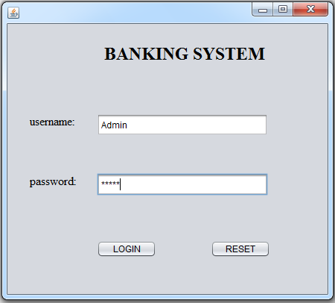

**2.Click login**

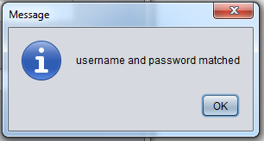

**3.Click reset**

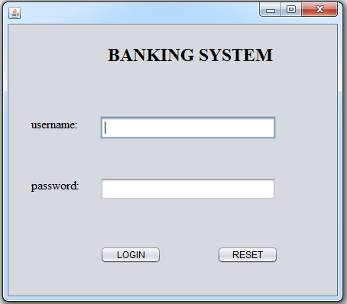

**4.wrong password and username**

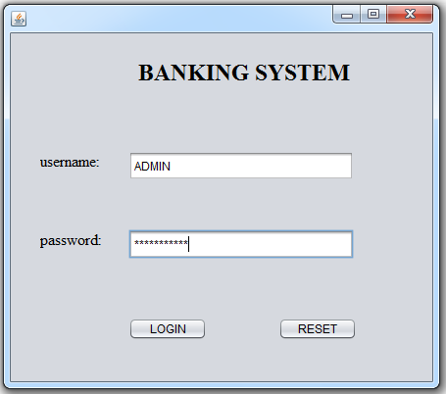

**5.click login**

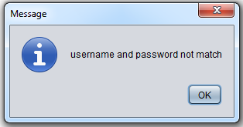

**\*USER LOGIN**

**1.empty**

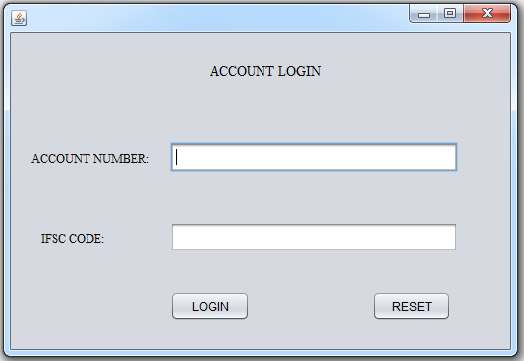

**2.Enter the account number&IFSC code**

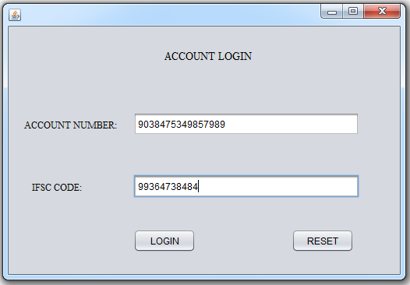

**3.click login**

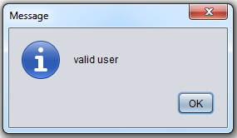

**4.enter the wrong number**

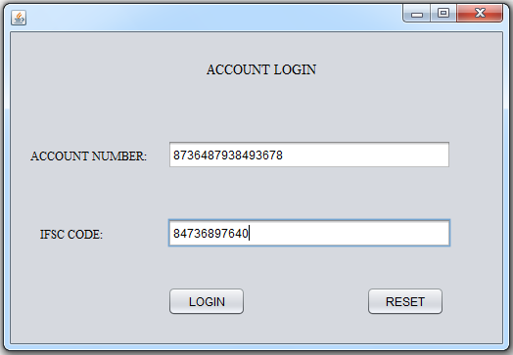

**5.click login**

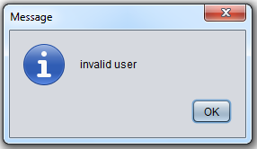

**6.click next……**

**\*ACCOUNT DETAILS**

**1.Account details**

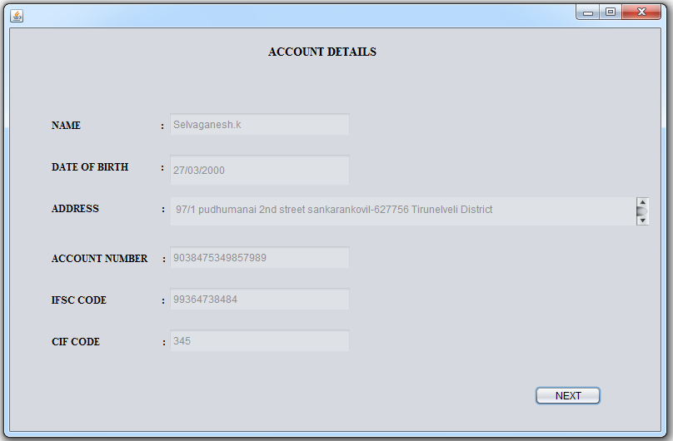

**2.click next…….**

**3.next page appear….**

**\*TRANSACTION DETAILS**

**1.Trans action details will appear**

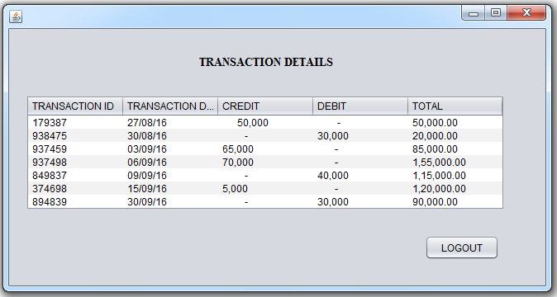

**2.click logout**

**CHAPTER –9**

**REFERENCE**

* [**https://www.scribd.com/doc/54024405/Project-Report-Banking-Management-System**](https://www.scribd.com/doc/54024405/Project-Report-Banking-Management-System)
* [**https://www.slideshare.net/nitishxavier11/synopsis-on-bank-management-system**](https://www.slideshare.net/nitishxavier11/synopsis-on-bank-management-system)
* [**http://www.ijstr.org/final-print/aug2015/Bank-Customers-Management-System.pdf**](http://www.ijstr.org/final-print/aug2015/Bank-Customers-Management-System.pdf)
* [**http://www.muengineers.in/computer-project-list/visual-basic-projects-list/bank-management-system**](http://www.muengineers.in/computer-project-list/visual-basic-projects-list/bank-management-system)